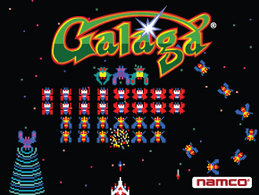Galaga

*Dylan Cauwels and Andrew Han*

*dmc3692 and ah47984*

# Overview

Using a starship, you shoot off enemies that rapidly progress toward you

## Basic Rules

1. If you are hit by either a ship or a projectile you lose a life
2. You have 3 lives (may reduce or increase life count based on difficult of game and amount of levels present)
3. All ships will enter in groups. Once all ships are present they will form up and begin to reattack in their entry formations.
4. Level will not finish until all ships are destroyed

## Features

1. Enemy Variation: There will be two types of enemies
   1. Basic: one shot kill, slow and attacks in groups
   2. Advanced: two shot kill, fast and attacks alone
2. Double Shot Power Up: will give the Player a double attack, where his/her ship shoots two lasers
3. Score Counter in top right corner
4. Life Counter in top left corner

## Difficulty

Difficulty will be adjusted by:

1. Manipulation of the lives the Player possesses
2. Frame rate
3. Speed of entry and attack of enemy ships
4. Maximum attack speed of Player Ship
5. Control of speed/frame rate